The joint East and West Central Europe
ISAE Regional Meeting Warsaw, 2018
“Animal preferences and animal welfare”

Registration form

PERSONAL INFORMATION
First Name
Last name (surname)
Institution / Organisation
Department
Address
City and code
Country
NIP (Institution Tax ID)*
Phone, e-mail
Abstract title
Warsaw Old Town guided tour (Yes / No)
Social dinner (Yes / No)
Zoo guided tour (Yes / No)
* If needed for receipt

Please fill out this form and submit to isae2018warsaw@ighz.pl
Please attach a proof of conference fee payment.
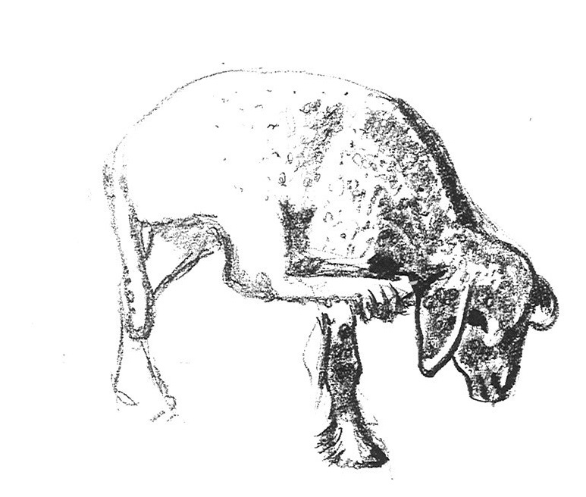
Correspondent bank details:
Bank Gospodarstwa Krajowego
Address: Al. Jerozolimskie 7, 00-950 Warsaw, Poland
For payment in PLN:
Bank account: 05 1130 1017 0020 1469 8820 0001
For payment in EUR:
Bank Account: 96 1130 1017 0020 1469 8820 0012
SWIFT: GOSKPLPW
Payment for: ISAE Regional Meeting Warsaw 2018 + participant name

